Project Design Phase-II
Data Flow Diagram & User Stories

Date | 31 January 2025
Team ID | LTVIP2025TMID38735
Project Name | Rice Type Detection System
Maximum Marks | 4 Marks

Data Flow Diagrams:
A Data Flow Diagram (DFD) is a traditional visual representation of the information flows within a system. A neat and clear DFD can depict the right amount of the system requirement graphically. It shows how data enters and leaves the system, what changes the information, and where data is stored.
Example: DFD Level 0 (Industry Standard)
Example: (Simplified)
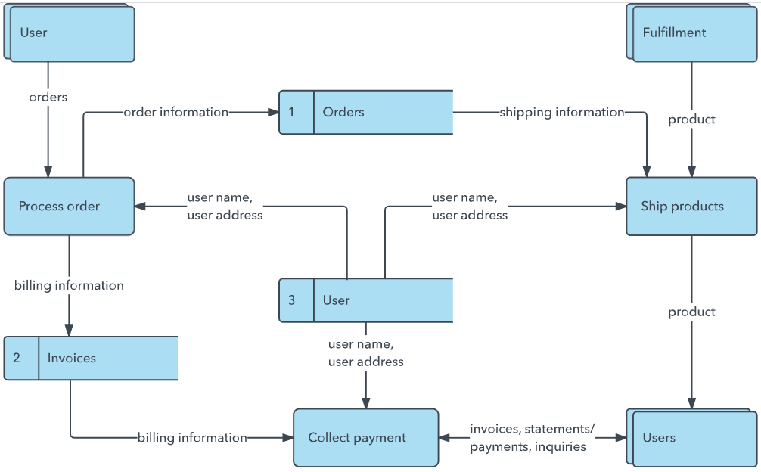


User Stories
Use the below template to list all the user stories for the product.
User Type | Functional Requirement (Epic) | User Story Number | User Story / Task | Acceptance criteria | Priority | Release
Customer (Mobile user) | Registration | USN-1 | As a user, I can register for the application by entering my email, password, and confirming my password. | I can access my account / dashboard | High | Sprint-1
 | Registration | USN-2 | As a user, I will receive confirmation email once I have registered for the application | I can receive confirmation email & click confirm | High | Sprint-1
 | Registration | USN-3 | As a user, I can register for the application through Facebook | I can register & access the dashboard with Facebook Login | Low | Sprint-2
 | Registration | USN-4 | As a user, I can register for the application through Gmail | I can register and access the dashboard with Gmail login | Medium | Sprint-1
 | Login | USN-5 | As a user, I can log into the application by entering email & password | I am able to access my dashboard after entering valid credentials | High | Sprint-1
 | Dashboard | USN-6 | As a user ,I can view a summary of my profile and prediction results | I can see profile info and recent rice type predictions | Medium | Sprint-2
Customer (Web user) | Dashboard Access |  | View predictions from uploaded images via web interface
Customer Care Executive | Support Panel |  | Respond to support tickets and access user queries
Administrator | Admin Dashboard |  | Manage user accounts, view analytics, and export rice detection logs

